NAME – Ekta Shukla

EMAIL ID – [shuklaekta811@gmail.com](mailto:shuklaekta811@gmail.com)

USER ID – 34746

**Application Packaging,Handling Scheduled Task,Windows 10/11, Logon Script + Active setup.**

Application Packaging helps organizations in need of a way to take the burden off their IT support teams while providing an improved end-user experience.

If we look over the Application Packaging benefits, we can find that it ensures a consistent, stable and reliable standard environment, increases the efficiency of software management by streamlining the software deployment along with any customization needed,mitigates security issues,decreases risks for business disruption.

end-to-end packaging process consists of 3 main steps:

1. Application Discovery

2. Application Packaging

3. UAT (User Acceptance Testing)

Extra step for quality – Review of the packages

Tools -MSI, MSIX and App-V

The new MSIX packaging format based on same concept of contenarization as App-V

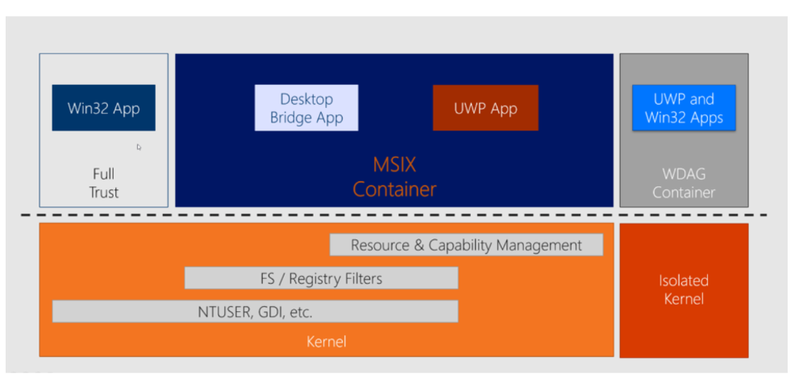

Application Compatibility Toolkit (ACT) - the tool developed by Microsoft to help enterprises fix application compatibility issues that may occur due to the changes between Windows Operating System versions

In MSI (Windows Installer), the context refers to the level of access a process or component has within the Windows operating system**.**

User Context: Limited access to the user's profile.

System Context: Full system-wide access.

Admin Context (Implied): Requires Admin privileges for system-wide changes

**Windows 11/10**

**Windows 11 benefits**

* Improved User Interface
* Enhanced Security
* Performance Improvements
* Modernized Microsoft Store
* Improved Multi-tasking
* Integrated AI Assistant
* Enhanced Gaming Experience
* Optimized update process

**Windows 10 benefits**

* Familiar Interface
* Wide compatibility
* Stability
* Cost Effective

**Handling Scheduled task**

Handling scheduled task within a windows MSI installation allows automating actions after deployment such as starting services running scripts or executing programs. This achieved by creating a scheduled task within the MSI that triggers at a specific time or event making it a powerful tool for post installation automation.

**USE CASES IN WINDOWS MSI**

* Starting services-Automatically start a service after installation.
* Running scripts-Execute a custom script that performs post installation tasks.
* Executing programs-Trigger the execution of a program after the installation is complete such as launching an application or running configuration avalibility.
* Running scheduled tasks at specific intervals-this allows for recurring tasks like backup data synchronization or system maintenance to be perform automatically.

**LOGON SCRIPT+ ACTIVE SETUP**

**1. Use of Active Setup**

* **Purpose**: Executes user-specific tasks at user logon
* **Action**: Copy files, update registry, run scripts within MSI.
* **Example**: Copy config files to AppData from machine-level location.

**2. Creating & Assigning Logon Scripts**

* **Script types**: .bat, .ps1 (PowerShell), .vbs – choose based on need.
* **Function**: Copy user files/settings from shared drive to user profile folder.
* **Assignment**: Use Group Policy to assign to:
  + Individual users
  + User groups
  + Organizational Units (OUs)

**3. Deployment Strategies**

* **Group Policy**:
  1. Assign logon scripts by user/group/OU.
  2. Distribute MSI that uses logon scripts/Active Setup.
* **Software Distribution**:
  1. Tools like SCCM or Intune can also deploy MSIs with scripts.
* **Language Choice**:
  1. Use batch for basic logic.
  2. Use PowerShell for complex actions (preferred for modern systems).

**4. Settings Deployment**

* **Need**: App needs to load user-specific settings at login.
* **Steps**:
  1. Add Active Setup in MSI to trigger script at login.
  2. Script copies settings from \\server\netlogon\MyApplication to %AppData%\MyApplication.
  3. Deploy via Group Policy or Software Distribution tool.

**5. Best Practices**

* **Error Handling**: Handle failures like network issues gracefully.
* **Security**: Protect sensitive file paths & credentials.
* **Testing**: Always test script in real user environments.
* **Documentation**: Record script logic, deployment method, and configuration.